Ch.4 lab 2 Exercises

# Task 1

Write a program with for loops that computes:

* The sum of all even numbers between 2 and 100 (inclusive).
* The sum of all squares between 1 and 100 (inclusive). (12 + 22 + 32 +.....)
* All powers of 2 from 20 up to 30. (220 + 221 + 222 +…)

# 

|  |
| --- |

|  |
| --- |

# Task Lab 2

Write a program that asks the user to enter a positive integer n and print the multiplication table for the first n numbers. This demonstrates nested loops

**Sample outputs:**

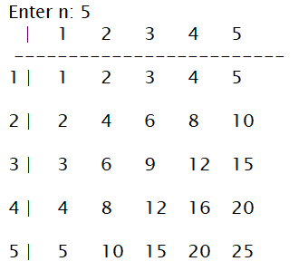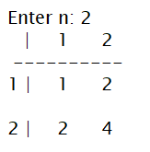

|  |
| --- |

|  |
| --- |

|  |
| --- |

# 

# Task **Lab 3**

Write a program that counts the number of vowels in a string using a while loop.

**Sample outputs:**

|  |
| --- |

|  |
| --- |

|  |
| --- |

|  |
| --- |

# 

# Task Lab 4

# Read a string from the user, then prints the number of lower-case and upper-case, digits, and special symbols in the string.

**Output:**



  
  

  
  

 